**Project Design Phase-II**

**Data Flow Diagram &User Stories**

|  |  |
| --- | --- |
| Date | 8 November 2022 |
| Team ID | PNT2022TMID34036 |
| Project Name | AI –powered Nutrition Analyzer for fitness Enthusiasts |
| Maximum Marks | 4 Marks |

**Data Flow Diagrams:**

A Data Flow Diagram (DFD) is a traditional visual representation of the information flows within a system. A neat and clear DFD can depict the right amount of the system requirement graphically. It shows how data enters and leaves the system, what changes the information, and where data is stored.

**Flow**

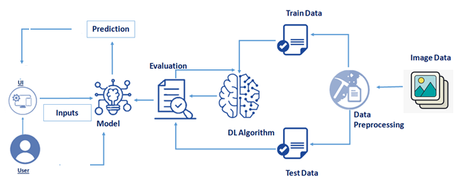

* It occurs when the body does not get enough food and enough necessary nutrients.
* It can lead to delayed growth and low weight.
* If a person does not get the right balance of nutrients, they can also have malnutrition. It is possible to have obesity.
* Fatigue is a common side effect of iron deficiency, which can lead to anaemia .
* poor nutrition can contribute to stress and tiredness.

**Data flow diagram**

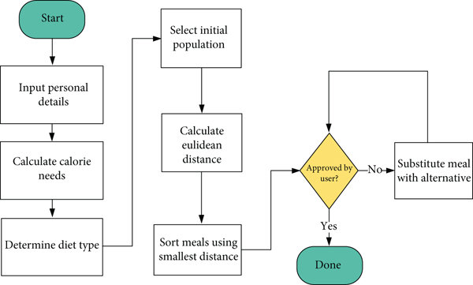

**User Stories**

Use the below template to list all the user stories for the product.

| **User Type** | **Functional Requirement (Epic)** | **User Story Number** | **User Story / Task** | **Acceptance criteria** | **Priority** | **Release** |
| --- | --- | --- | --- | --- | --- | --- |
| Patient | Collect patient details | USN-1 | Collect the information about the client’s medical history | It is necessary to collect the correct data | High | Sprint-1 |
|  |  | USN-2 | Collect the information about dietary practices | It is necessary to collect the correct data | high | Sprint-2 |
|  |  | USN-3 | Collect the information about current treatment and food security | It is necessary to collect the correct data | Medium | Sprint-1 |
|  | Implement algorithm | USN-4 | Identify algorithm | Accuracy of algorithm calculated so that it is easy to obtain most accurate output. | High | Sprint-1 |
|  |  | USN-5 | Evaluate the dataset | Data is evaluated before processing | Medium | Sprint-1 |
|  | Evaluate Accuracy of Algorithm | USN-6 | Identify accuracy ,precision,recall of each algorithms | These values are important for obtaining the right output | High | Sprint-3 |